

A
Project Report
On
Online Shoping Cart

Prepared
By
Amit Bhadauria
Ritul Sutaria
Manoj Banugaria

College
Shree M.N. Virani Science College

Submitted
To
Saurashtra University

Guided
By
Kalpesh Padariya

CONTENTS

- Certificate
- Acknowledgment
- Preface
- Objectives & Miscellaneous information
- Project Specification
- Software Study
  - About ASP.Net
  - Internet
  - Scripting Language
  - Web Browser
  - HTMLl
  - Web Page
Static & Dynamic
- Web Server
ASP.NET
- Tables of database
- Screen Layout

ACKNOWLEDGEMENT

Most successful feats involve efforts of many people. This Project is no exception. It is our pleasure to take this opportunity to thank all those who helped us directly or indirectly in development of the project.
Firstly Shree M.N Virani Science College, Saurashtra University, Rajkot for giving us a chance to obtain project. It was a nice experience and it helped get idea of the Real time Systems and their development procedure.
We are very much thankful to our Project guide Prof. Kalpesh Padariya , Our Lecturer for his unconditional and unbiased support. He explained us about the System and guides me during the entire Project. His constant encouragement and co-operation have been a source of inspiration for me all the time.
And finally, our sincere thanks to our batch-mats, who had provided us with innumerable discussions on many technicalities and friendly tips. Without their cordial and friendly support, this activity has been much tougher.
We are also thankful to our Parents, Friends and Others for their opinions and support in the system.
The project has given us immense knowledge to use in our future ventures and many moments to cherish.

Amit Bhadauria
Ritul Sutaria
Manoj Banugaria
PREFACE

The age of information has gone the correct area is the age of knowledge. These having knowledge would higher resources from the society & at the same time would be earning the higher returns But knowledge as we know has changed drastically, to ensure that knowledge is imported to student, it is made mandatory by Shee M.N.Virani Science College for MSc (IT & CA) student to work on a comprehensive project.
Here is the detailed report and web Site of Online Shoping Cart. It has developed on ASP.NET
Finally, we would like to express our gratitude for the support and encouragement I have receives from them. The improvement would always be welcome.

Amit Bhadauria
Ritul Sutaria
ManojBanugaria

PROJECT SPECIFICATIONS

Project Title : Online Shoping Cart

Institution : Shree Virani Science College
(Saurashtra University, Rajkot)

Front End Tool : ASP.NET

Back End Tool : MS Access

Documentation Tool : Microsoft Word 2003

Operating System : Microsoft Windows XP

Web Server : ASP.NET

Web Browser : Internet Explorer 6.0 or Opera

Requirements : Platform:
Microsoft Windows 9x, XP, NT and onwards
Hardware:
32-bit Processor, 1.8 GHz
512 MB RAM,

Submitted By : Ritul Sutaria
Manoj Banugaria
Amit Bhadauria

Submitted To: Shree M.N. Virani Science College
(Saurashtra University, Rajkot
SOFTWARE STUDY

About ASP.NET
ASP.NET is the .NET framework layer that handles Web requests for specific types of files, among those are .aspx and .ascx, and .asmx extensions as well as several others (you can get the full list by checking the Application Configuration properties for the Web site in the Internet Services Manager application). The ASP.NET engine provides a robust object model for creating dynamic content and is loosely integrated into the .NET framework. This integration makes it easy to change the implementation when the .NET framework migrates to platforms other than Windows.
ASP.NET is implemented in an assembly that exposes classes and objects that perform predetermined specific tasks. If you are familiar with "classic" ASP (the versions of ASP that preceded .NET), you'll find thatyour approach to programming in ASP.NET is somewhat different, but the concepts behind building aWeb application are much the same. If you're not familiar with classic ASP, so much the better— you won't have as much information to forget!
ASP.NET programs are centralized applications hosted on one or more Web servers that respond dynamically to client requests. The responses are dynamic because ASP.NET intercepts requests forpages with specific extensions, for example .aspx or .ascx, and hands off the responsibility for answering those requests to just-in-time (JIT) compiled code files that can build a response on-the-fly.
The server doesn't "serve" any of these file types— it returns the appropriate content type to the client. The configuration file types contain initialization and settings for a specific application or portion of an application. Another configuration file, called machine.web, contains machine-level initialization and settings. The server ignores requests for Web files, because serving them might constitute a security breach. Server to load, parses, and executes code to return a dynamic response. For Web Forms, the response usually consists of HTML or WML. For Web Services, the server typically creates a Simple Object Access Protocol (SOAP) response. While SOAP requests are inherently stateless and can thus execute immediately, Web Forms are stateful by default. Web Forms maintain state by round-tripping user interface and other persistent values between the client and the server automatically for each request. In
Form can use ViewState, Session State, or Application State to maintain values between requests. It is possible (but not the default) to take advantage of ASP.NET's state maintenance architecture from a Web Service, but for performance reasons, you should generally avoid doing so. Both Web Forms and Web Services requests can take advantage of ASP.NET's integrated security and data access through ADO.NET and can run code that uses system services to construct the response.
The major difference between a static request and a dynamic request is that a typical Web request references a static file. The server reads the file and responds with the contents of the requested file.
With ASP.NET there's no such limitation. You don't have to respond with an existing file— you can respond to a request with anything you like, including dynamically created HTML, Extensible Markup Language (XML), graphics, raw text, or binary data— anything. Capability, by itself, is nothing new— you've been able to create CGI programs, JavaServer Pages, classic ASP pages, ColdFusion, and Net- Objects Fusion pages for quite some time. All these technologies give you the capability to respond to an HTTP request dynamically. So what are the differences? Unlike classic ASP, ASP.NE uses .NET languages. Therefore, you have access to the full power of any .NET assembly or class in exactly the same way as you do from any other Windows application written in C#. In this sense, ASP.NET is similar to early compiled CGI programs, but with CGI, a separate copy of the program had to be loaded and executed for each request. ASP.NET code exists in multithreaded JIT-compiled DLL assemblies, which can be loaded on demand. Once loaded, the ASP.NET DLLs can service multiple requests from a single in-memory copy. An ASP.NET supports all the .NET languages (currently C#, C++, VB.NET, and JScript, but there are well over 20 different languages in various stages of development or deployment for .NET), so you will eventually be able to write Web applications in your choice of almost any modern programming language. In addition, there are open source groups working with Intel and Hewlett-Packard to support .NET on various flavors of Unix and Linux. JavaServer Pages support only Java, but because Java now has a wide support base, that's not much of a limitation. Java Servlets are more like ASP.NET but offer little support for state maintenance, Web Services, or XML. In addition, no Java design environment competes in features and quality to Visual Studio. An Classic ASP supported several scripting languages, although in practice, VBScript and JScript were by far the most prevalent. Although the scripting languages you could use with classic ASP were untyped, interpreted, and not particularly powerful, you could extend ASP's basic functionality by writing DLLs in any COM-compliant language. Another ASP.NET competitor, ColdFusion, uses
ColdFusion Markup Language (CFML) tags, which have a powerful but limited set of capabilities; however, you can extend CFML with custom programming in C++ or Java. Microsoft was able to draw on millions of hours of developer experience with classic ASP, so in addition to huge increases in speed and power, ASP.NET provides substantial development improvements, such as seamless server-to-client debugging, automatic validation of form data, and a programming model very similar to that of a Windows application.

ASP.NET integration with .Net Framework

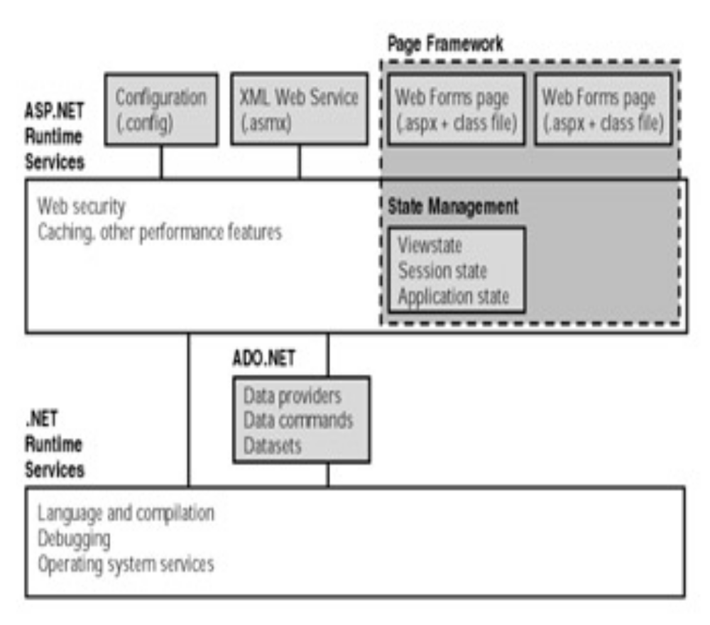

Introducing Internet:
Millions of people throughout the world use the Internet. They use it for communication with individuals and with groups to share information and ideas by electronic mail (E-mail).
They use it to other computer system so they can look up information and retrieves files, documents, data, programs and images. They use it to search for information on all sorts of topics in the arts, recreation, humanities, business, the science and social issues. All this activity is possible because tens of thousands of networks are connected to the Internet and exchange information in the same basic ways.
- E-mail (Electronic Mail):
An efficient and convenient means of user-to-user communication Communication is possible through many media’s like audio, video, text etc….
- Telnet:
Allow you to connect to and log into a remote computer on the Internet to another. FTP stands for file transfer protocol. Many systems on the Internet make archives or collection of files available through anonymous FTP. Its use “Anonymous FTP: Retrieving files from other computer.”
- Gopher:
An individual uses Gopher to access various types of information such as files, documents, address books and images. Gopher also allows accessing FTP, TELENET and searchable database.

- World Wide Web:
This gives hypertext, even hypermedia, access to all varieties of resources and services on the Internet. There are several program used to work with the Internet in this fashion including Lynx and Mosaic. The www is no a tool,

program or service but a way of viewing and accessing the Internet. Even with this vies you need to know about the basic services you will access.
- How Internet Works?
The Internet is designed so the computer systems within one network can exchange information with computer on other networks. The rules that govern this form of communications are called protocols. Using him same protocols allows different types of networks and computer systems to communicate with each other. Each needs to have the software and hardware in place so it can deal with information in the form specified by the protocols, transform information from the protocol’s from its own form. And be able to send and receive information in that form. Two protocols used are Internet protocols (IP) and Transmissions control protocol (TCP).
- Internet Domain Name and Address :
Network and computer systems on the Internet exchange data and communicate with each other. Address is assigned to each network and each computer system within a network gets and address based on the network’s Address. These assesses are made up of a sequence of four number separated by period, much as 182.56.245.76. Each number is in the range of 0 to 255. Starting from the left the numbers in the address identify a specific host or computer systems.
An address is numeric form is called IP address. Information sent from one site on the Internet to another is divided into packets and each packet has IP address of sender and the IP address of the destination.
This numeric scheme of IP address works well for computer system, but it’s difficult for people to remember and type needs to contact. Therefore, Internet site also have names associated with them for example, Jupiter.research.wonder.com or cs.greatu.edu. The name is called a domain name. Like the numeric address, domain name are a sequence of words separated by periods.

The collection of networks making up the Internet is divided into groups called domains. The domains represent either a type of organization or a
Geographical location For example, a site in the domain TX We would be in Texas in the united sates. Each IP address is associated with one or more domain name is automatically converted to the IP address. The name of a specific computer system of host on a network is called fully qualified domain name.

- Business Over Internet:
The Internet is the only interactive form for the repaid exchange of information; the fastest communication is possible through the Internet. The advantage of using Internet for communication purpose is its widely acceptance and cheap media compared to others. We can send and receive large amount of information in data form. Business can be provided. The boggiest advantage of using it is that lost of third parties, who were used involved in business, can be discarded now. Customer can directly reach the manufactures of directors of company.
Companies in search of other market will do well to research the Internet market place threw, to insure that there are sufficient numbers of their target group on line to justify the commitment and the budget. Through effective advertisement, one can reaches out to greater number of customers. It’s hard to submit papers, brochures and pamphlets to large number of audience but through Internet presence will ring any company exposure to a new medium. There is long term, viable medium. Companies will do better and management will also try to improve their skill to survive in the healthy competition. The company should be having a long-term vision, unless it cannot start earning from the very first day. They must Intent to test the marketing strategies, explore of the Internet and keep an eye on developing technologies that might be of use is not too distant future.
There is one important difference is marketing on the Internet versus the other primary media. The difference is the ability within the
Internet to perform low cost continuous promotion of your presentation. This is not easily available through the traditional media. The result in a constant flow of visitors to your site or message. Internet proves to be the best media for getting the technical support for the product that your use software development companies distribute the trial version of their software free on Internet as freeware or sharewares. Marketing and selling of providing information to the customers are all the activates that can boost yours business.

Feasibility Study:

Feasibility study of the desired system was done next.
They are of 3 types:
- Technical
- Operational
- Economical

Technical feasibility considers whether the desired project can be completed within the framework of available technology. As our project was website designing, this was not much of a problem, as many advanced web-editing tools are available.

Operational feasibility was done to assure that the product that would be developed would be used. Since a cards and gifts has to have a website of its own sooner or later, that wasn’t much of a problem.

Our Commercial Website is Economically Feasible Because
We have developed this website only for one time. Only future enhancement is required on the other hand every client can view our site any time or many time as per their requirement. So the future economical expenses are null. So we can say that this website is totally economically feasible

Introduction to Markup Language :
- About HTML :

Hyper Text Mark-up Language (HTML) is a standard language.
For creating Web pages. It provides numbers of command that can be used to place and format text, picture and sounds on web pages. The linked to other document on the internet.
A web-browser is a program that automatically interprets the html code & formats the document appropriately. This process of interpreting the commands &displaying a web page appropriately is known as rendering.
HTML documents are typically written in HTML.You can use many text Editor and save the document with ‘html’ or ‘htm’ extension. After entering HTML code in a file you can view it using any internet Browser.
Without HTML the World Wide Web wouldn’t exist.Html allows the individual elements on the web to be brought together and presented as a collection. Text images, Multimedia and other files and all are packed together using html.

Understanding HTML:
- HTML was originated by Tim Berners-Lee.
- HTML developed a few years ago as a subset of SGML (Standard Generalized Mark-up Language) which is a higher-level mark-up language that has long been a favorite of the Department of Defense.
- Any HTML document is also valid for SGML.
- HTML is a Hyper Text Markup Language that is used to develop web pages.
- HTML is not a programming language like C, C++ and Java etc.
- It is a cross platform markup language that is design to be flexible enough to display text and other elements like graphical on a variety of views.
- The HTML documents consist of special Tags that are embedded in an ASCII document.
- These Tags are interpreted by web browser like Internet Explorer, Netscape Navigator etc.
About Web Browsers
- Internet Explorer:
The IE is a browser provided by the Microsoft Corporation, which lets the users to browser through the web pages. In other words, we can say that it is a means by which one can visit web pages or web sites.
With an Internet connection and Internet Explorer, you can find and view information about anything on the Web. Just click the topics below to get started.
Internet Explorer makes it easier to get the most from the World Wide Web, whether you are searching for new information or browsing your favorite Web sites. And built-in IntelliSense technology can save you time completing routine Web tasks, such as automatically completing Web addresses and forms for you, and automatically detecting your network and connection status.
In addition to Microsoft Windows accessibility products and services, the following features make Internet Explorer more accessible for people with disabilities. All features in Internet Explorer are accessible to you by using the keyboards or the mouse.

- Opera:
Opera is the browser, which allows the users to get information around the web.
- Features of Opera are as follows: -
  - Great speed
  - High security
  - Tabbed browsing
  - Flexible pop-up blocker
  - Effective Spam filter
  - The opera browser is fast, secure and user-friendly
  - Available in 20 languages
.
Introduction of Web Page:
A Web page is a hypermedia document. It is a specific implementation, though, that has its own characteristics.
HTML (Hypertext Markup Language) describes a web page, which is store in plain text file with the HTM or HTML file extension. The primary purpose of HTML is to describe how to format the contain of web page. For example, HTML tags specify when text is displayed with emphasis or when a block of text is formatted as a heading. Some HTML tags also cause the web browser to display an image or to format content as a table. Most importantly, HTML tags can link a word or phrase to other document on the Internet. In short, a Web page is combination of text and HTML tags that format that text.
The big attraction with Active Server Pages, of course, is the ability to include script directly in the file that’s referenced by the browser, and thereby creates dynamic pages. It’s important to recognize how ASP differs from existing methods such as referencing a static page, executing CGI and ISAPI applications, or running traditional scripts.
There are two types of web pages.
- Static Page
- Dynamic Page
  - Static Page :
When the user enters URL into their browser’s address box, or clicks a hyperlink on another page, a request for that page is sent to the server. This is just a file on the server’s disk, and the web server software starts by loading it into memory. If it’s a normal static HTML page, the server adds a few transmission protocol requirements such as the document type, encodes it so that it can be transmitted over HTTP, and sends the whole thing to the browser. The user sees the contents as rendered HTML page, but the source is the same is the same as the file that is stored on the server’s disk.
- Dynamic web pages:
To create a dynamic page using traditional methods, the server has to do more than just package up and send a file from disk. If the request from the browser is for a CGI or ISAPI application file, the server loads the application and executes it. The application itself creates a stream of text and HTML code, just like it was sending it to a printer. This is assembled into a temporary page on the server, packaged up for HTTP transmission, and sent to the browser. To the user, it looks just like a normal static page, because it’s still just HTML code. However, the actual page is no longer just a copy of the file on the server’s disk.
It is created ‘on the fly’, and the page can be different each time the application that creates it is referenced.

Introduction of Web Server:

WEB
SERVER
CLIENT 22 22
SERVER

CLIENT
CLIENT 22 22
SERVER

A Web Server is a computer that runs the Web server software, which responds to page requests. It is also called host. The two main types of Web Server are HTTP Server that follow the HTTP protocol, and FTP Servers that follow the FTP protocol.
A Web Client sends requests for data to a web server. When the web server processes the request and sends the requested page to the client (remember the browser is used to view these pages and send requests).

DIGITAL CERTIFICATION

OBTAINING A DIGITAL CERTIFACATION

A digital certificate, also know as a SSL Server Certificate enables SSL (Secure Socket Layer encryption) on the web server. SSL protects Communications so you can take credited cards orders security and ensure that hacker cannot eavesdrop on you. Any e-commerce company wills require you to have SSL before you can use any services
Thankfully, for most people obtaining a digital certificate is not a problem. For a minimal fee, one can usually use the certificate owned by the web hosting company where your page resides.
If you are a larger company, however, you may want to get your own digital certificate. A certificate costs about $125.00 and can be obtained form Thwarted or Version.
DIGITAL CERTIFICATE CONTENTS

Owner’s Identifying Information:
Name, Organization, Address
Issuing authority’s digital signature
And ID Information
Owner’s public key

Date of Validity of Digital ID

Class of Certificate

Digital ID Certificate Number

Certificate authority such as Veiling, Cyberturst, and Nortel issue digital certificate.As shown in figure, a digital certificate authority, a public key for cryptographic use, a time limit for the use of certificate, and the digital certificate identification number.

A digital certificate can be issued in one of four classes, indicating to what degree the older has been verified. Class 1 is the easiest to obtain because it involves the fewest checks on the user’s background; only the name and e-mail address are verified. For a Class 2 certificate, the issuing authority checks a driver’s license, social security number, and date of birth. Users applying for a Class 3 Certificate can expect the issuing authority to perform a credit check in addition to the information required for a Class 2 certificate, a Class 4 Certificate includes information about the individual’s position within an organization, but the verification requirements for these certificates have not yet been finalized. The verification requirements for these certificates have not yet been finalized.

User must pay a fee to obtain a digital certificate from commercial or governments certificate authorities; the fees increase for the higher classes, partly because of the effort required to check the user’s background. Because of the background checks accompanying the higher classes, these class certificates serve as stronger affirmation of the user’s identity.

Terms and Conditions of site

The site is a public site with free access and Perfect Jobs assumes no liability for the quality and genuineness of responses. Online Shoping cannot monitor the responses that a person may receive in response to information he/she has displayed on the site. The individual/company would have to conduct its own background checks on the bonafide nature of all response(s).

Online Shoping cart will not be liable on account of any inaccuracy of information on this web site. It is the responsibility of the visitor to further research the information on the site. Any breach of privacy or of the information provided by the consumer to Online Shoping cart to be placed on the website by technical or any other means is not the responsibility of Online Shoping cart does not guarantee confidentiality of information provided to it by any person acquiring/using all/any information displayed on the naukri.com website or any of its other websites / domains owned and operated by Online Shoping cart

Online Shoping cart does not share personally identifiable data of any individual with other companies / entities except with those acting as our agents in providing our Service to you or by recruiters who contact you through the details provided by you on Resume Manager. Online Shoping cart shall share all such information that it has in its possession in response to legal process, such as a court order or subpoena.

The user shall not utilize the services offered by Online Shoping cart.com in any manner so as to impair the interests and functioning of Online Shoping cart.com. The user undertakes not to duplicate, download publish, modify and distribute material on Online Shoping cart.com unless specifically authorized by in this regard. The user undertakes not to establish any deep link or other connection to any specific page of Online Shoping cart.com other than the Home Page without obtaining prior consent of it.The user undertakes to use naukri.com for his/her own purposes. Using content from Online Shoping cart.com for derivative works with a commercial motive without prior written consent from Online Shoping cart.com is strictly prohibited.

Users shall not spam the database maintained by Online Shoping cart or indiscriminately and repeatedly forward mail that may be considered spam etc. etc. Any conduct of the user in violation of this clause shall entitle IEIL to forthwith terminate all services to the user without notice and to forfeit any amounts paid by him.

The User is solely responsible for maintaining confidentiality of the User password and user identification and all activities and transmission performed by the User through his user identification and shall be solely responsible for carrying out any online or off-line transaction involving credit cards / debit cards or such other forms of instruments or documents for making such transactions and Online Shoping cart assumes no responsibility or liability for their improper use of information relating to such usage of credit cards / debit cards used by the subscriber online / off-line.

The User is solely responsible for obtaining, at his own cost, all licenses, permits, consents, approvals and intellectual property or other rights as may be required for using the Service.

Online Shoping cart reserves its right to amend / alter or change all or any disclaimers or terms of agreements at any time without any prior notice. All terms / disclaimers whether specifically mentioned or not shall be deemed to be included if any reference is made to them.

Online Shoping cart further reserves its right to post the data on the website naukri.com or on such other affiliated sites and publications as Online Shoping cart may deem fit and proper at no extra cost to the subscriber / user.

cart
Total Items | Product_id | Quantity | Total_billd | Date
2 | 0 | 0 | 0

Database Tables

- Cart

- Customer Detail

customer_detail
cust_id | Fname | Lname | Address | mobile_no | alt_email | city | state | country
1 | Ritul | Sutaria | Dhari | 9904323381 | Ritul@yahoo.com | Dhari | Gujarat | India
2 | Manoj | Banugaria | Talala | 9904324491 | Manoj@yahoo.com | Talala | Gujarat | India
3 | Amit | Bhadauria | Rajkot | 9993145583 | Amit@gmail.com | Rajkot | Gujarat | India

- Login

Login
UserId | Password | Conformed
1 | Ritul | Ritul
2 | Manoj | Manoj
3 | Amit | Amit

- Product List

product list
ID | product_id | quentity
1 | 100 | 1
2 | 101 | 2
3 | 102 | 3
4 | 104 | 4
5 | 105 | 2
6 | 102 | 5

- Product Master

Product_Master
Product_id | Product_name | Brand | Category | Sub_Category1 | Big_img | Product_info | Quentity | Price
2 | Hard Disk | Samsung | Hardware | Hard Disk | 2.jpg | Samsung 80 Gb Hard Disk | 10 | 2500
3 | Mouse | LogiTech | Hardware | Mouse | 3.jpg | Wireless Optical Optical Mouse | 50 | 500
4 | CD Drive | Sony | Hardware | CD Drive | 4.jpg | 52x Faster Cd-Drive | 25 | 3200
5 | Printer | HP | Hardware | Printer | 5.jpg | Laser Color Printer Hp | 10 | 5200
6 | PhotoShop | Adobe | Software | Designing | 7.bmp | Adobe photoshop CS2 For Editing image vary Easy | 50 | 500
7 | ImageReady | Adobe | Software | Designing | 7.bmp | Adobe photoshop ImageReady For Editing image vary Easy | 50 | 500
9 | Nokia 2600 | Nokia | Mobile | Nokia | 9.gif | Nokia 2600 Color Display With Loud Speaker Extra Time Bettry | 10 | 2500
11 | Sony Web Cam E8912 | Sony | WebCam | Webcam | 11.jpg | Hi Resolution Image Solution, Web Cam With 1MegaPixel | 15 | 750
12 | Samsung Golden Eye 932g | Samsung | Music | Tv | 12.jpg | Hi Resolution Image Solution, SamSung Golden Eye Tv With Flat Screen 5.1 Channal | 10 | 11000
13 | Cannon 5050i | Cannon | Digital | Camera | 13.JPG | Cannon 5050i Camera with 5 MegaPixel resolution, AutoFocus With Lcd Display | 10 | 15000
14 | Sony E106 | Sony | Digital | Camera | 14.JPG | Sony E106 Camera with 7.5 MegaPixel resolution, AutoFocus With Lcd Display | 10 | 17000
15 | HP LapTop | Hp | Hardware | LapTop | 15.JPG | 17" Hp LapTop DualCore Processor, 1Gb RAM 250Gb HDD, Soft KeyBoarb, | 5 | 45000
16 | Dell LapTop | Dell | Hardware | LapTop | 16.JPG | 17" Dell LapTop DualCore Processor, 2Gb RAM 250Gb HDD, Soft KeyBoarb, Extara Optical Mouse | 5 | 45550
17 | Toshiba i158 LapTop | Toshiba | Hardware | LapTop | 17.JPG | 17" Toshiba LapTop DualCore Processor, 512Gb RAM 250Gb HDD, Soft KeyBoarb, Extara Optical Mouse | 5 | 45550
18 | Apple Stereo HeadPhone | Apple | Music | HeadPhone | 18.JPG | Apple Stereo HeadPhone With Mega Bass And Tribble , Trully Entertainment | 50 | 500
19 | Intex 5.1 HomeTheatre | Intex | Music | HomeTheatre | 19.JPG | Intex 5.1 4500W HomeTheatre, MegaBass Environment, | 30 | 3500
20 | Samsung 6.1 HomeTheatre | Samsung | Music | HomeTheatre | 20.JPG | Samsung 6.1 4500W HomeTheatre, MegaBass Environment, | 30 | 4500
21 | Videocon 5 in 1 | Videocon | Music | 5 in 1 | 21.JPG | Videocon 5 in 1 with stereo channal, 3 CD Changer ,CD Coping Facility | 7 | 7500
22 | Sony J300i | Sony | Mobile | Sony | 22.jpg | Sony J300i with softy music, GPRS connectivity, MP3 support | 10 | 3900
1100 | Nokia 1100 | Nokia | Mobile | Nokia | 8.jpg | Nokia 1100 With Search Light White Display | 10 | 1300
6600 | Nokia 6600 | Nokia | Mobile | Nokia | 10.gif | Nokia 6600 Color Display With Loud Speaker Extra Time Bettry | 10 | 4500
9200 | Nokia 9200 | Nokia | Mobile | Nokia | 6.gif | Nokia 9200 | 5 | 25000

7) Temp

temp
id | orderid | productid | qty | name | price
2 | 0 | 2 | 5 | Hard Disk | 12500
3 | 0 | 4 | 4 | CD Drive | 12800
7 | 0 | 3 | 4 | Mouse | 2000
8 | 0 | 4 | 4 | CD Drive | 12800
10 | 0 | 4 | 8 | CD Drive | 25600
12 | 0 | 2 | 4 | Hard Disk | 10000
14 | 9 | 3 | 56 | Mouse | 28000
15 | 9 | 10 | 5 | Nokia 6600 | 22500
16 | 10 | 4 | 3 | CD Drive | 9600
17 | 11 | 6 | 4 | PhotoShop | 2000
18 | 12 | 2 | 1 | Hard Disk | 2500
19 | 12 | 3 | 5 | Mouse | 2500
21 | 13 | 2 | 4 | Hard Disk | 10000
22 | 14 | 15 | 5 | HP LapTop | 225000
23 | 15 | 3 | 1 | Mouse | 500
24 | 16 | 15 | 1 | HP LapTop | 45000
25 | 17 | 2 | 1 | Hard Disk | 2500
26 | 18 | 15 | 1 | HP LapTop | 45000
28 | 19 | 3 | 1 | Mouse | 500
29 | 20 | 3 | 1 | Mouse | 500
30 | 20 | 22 | 1 | Sony J300i | 3900
31 | 20 | 7 | 1 | ImageReady | 500
32 | 21 | 2 | 1 | Hard Disk | 2500
33 | 22 | 15 | 1 | HP LapTop | 45000
34 | 23 | 2 | 1 | Hard Disk | 2500
35 | 24 | 2 | 1 | Hard Disk | 2500
36 | 25 | 5 | 1 | Printer | 5200
37 | 26 | 4 | 1 | CD Drive | 3200
38 | 27 | 2 | 1 | Hard Disk | 2500
39 | 28 | 2 | 1 | Hard Disk | 2500
40 | 29 | 4 | 1 | CD Drive | 3200
41 | 30 | 15 | 1 | HP LapTop | 45000
42 | 31 | 15 | 1 | HP LapTop | 45000
43 | 32 | 2 | 2 | Hard Disk | 5000
45 | 32 | 9 | 1 | Nokia 2600 | 2500
46 | 33 | 2 | 1 | Hard Disk | 2500
47 | 33 | 22 | 1 | Sony J300i | 3900
48 | 34 | 4 | 1 | CD Drive | 3200
49 | 35 | 2 | 1 | Hard Disk | 2500
50 | 36 | 4 | 1 | CD Drive | 3200
51 | 37 | 2 | 1 | Hard Disk | 2500
52 | 37 | 15 | 2 | HP LapTop | 90000
53 | 37 | 4 | 1 | CD Drive | 3200
54 | 38 | 2 | 1 | Hard Disk | 2500
55 | 38 | 15 | 1 | HP LapTop | 45000
56 | 39 | 2 | 1 | Hard Disk | 2500
57 | 39 | 3 | 1 | Mouse | 500
58 | 40 | 2 | 1 | Hard Disk | 2500
59 | 40 | 15 | 1 | HP LapTop | 45000
60 | 41 | 15 | 1 | HP LapTop | 45000
61 | 41 | 4 | 1 | CD Drive | 3200
62 | 42 | 15 | 1 | HP LapTop | 45000
63 | 42 | 15 | 1 | HP LapTop | 45000
64 | 43 | 15 | 1 | HP LapTop | 45000
65 | 43 | 15 | 1 | HP LapTop | 45000
66 | 44 | 5 | 1 | Printer | 5200
67 | 44 | 1100 | 1 | Nokia 1100 | 1300
68 | 44 | 19 | 1 | Intex 5.1 HomeTheatre | 3500
69 | 44 | 13 | 1 | Cannon 5050i | 15000
70 | 45 | 2 | 13 | Hard Disk | 32500
71 | 45 | 3 | 1 | Mouse | 500
72 | 46 | 16 | 1 | Dell LapTop | 45550
73 | 46 | 1100 | 1 | Nokia 1100 | 1300
74 | 47 | 13 | 1 | Cannon 5050i | 15000
75 | 47 | 2 | 1 | Hard Disk | 2500
76 | 47 | 5 | 1 | Printer | 5200

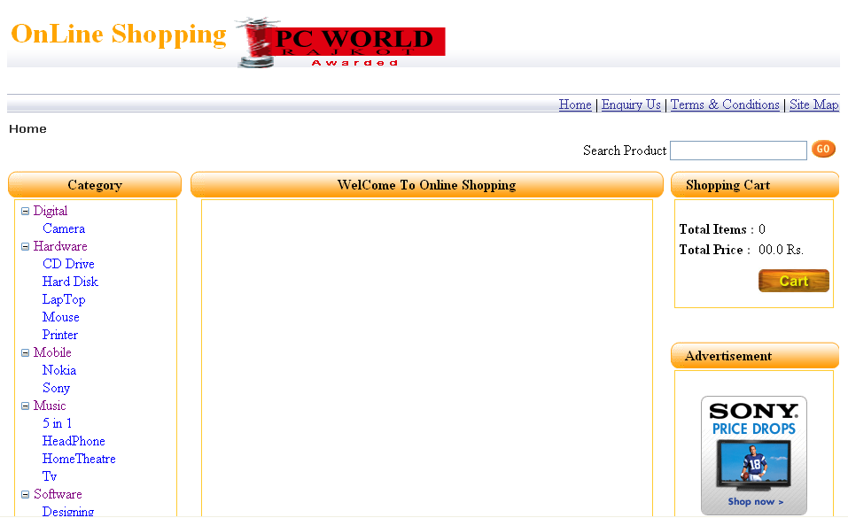
Home Page
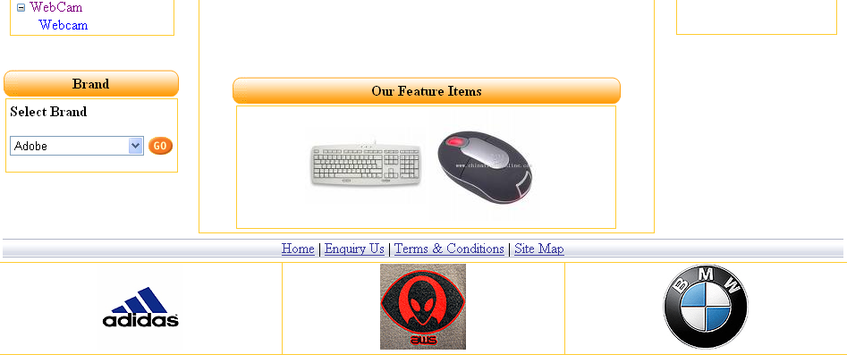

Snipat of Home Page

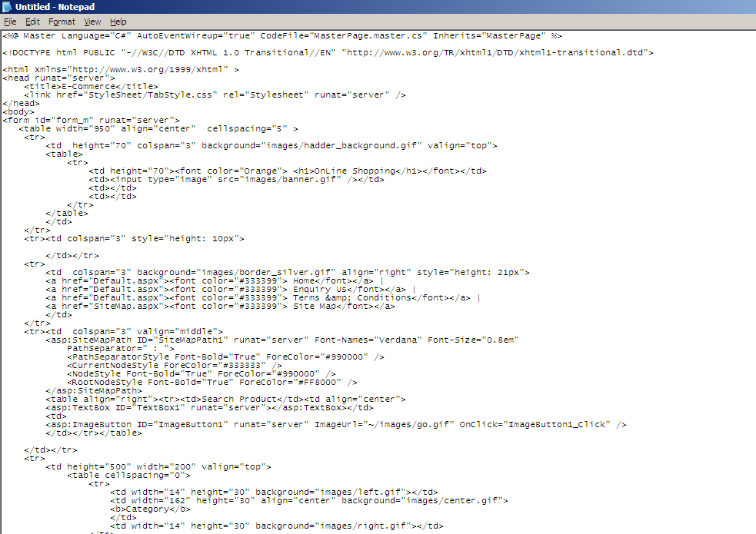

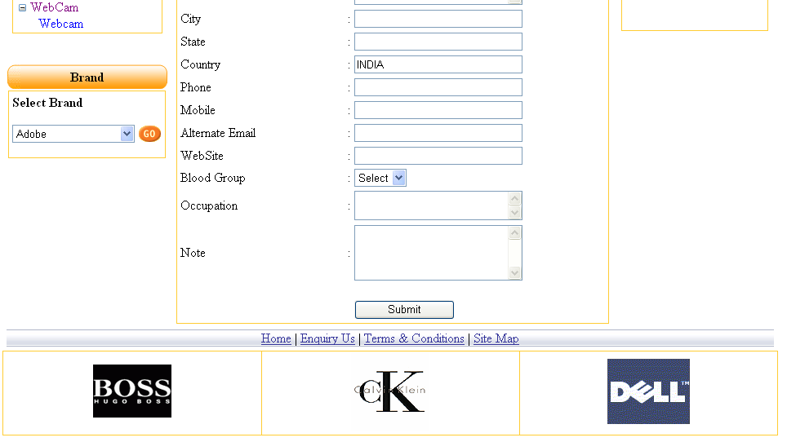
Registration Form
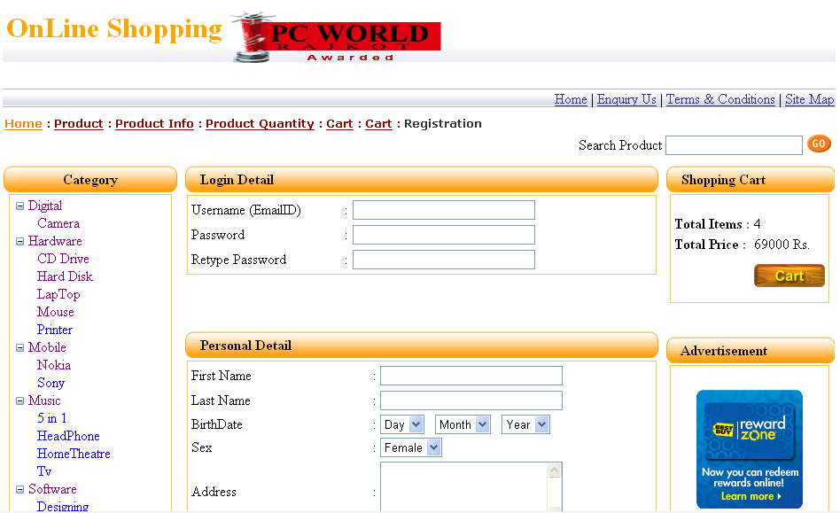

Registration Form Snipat
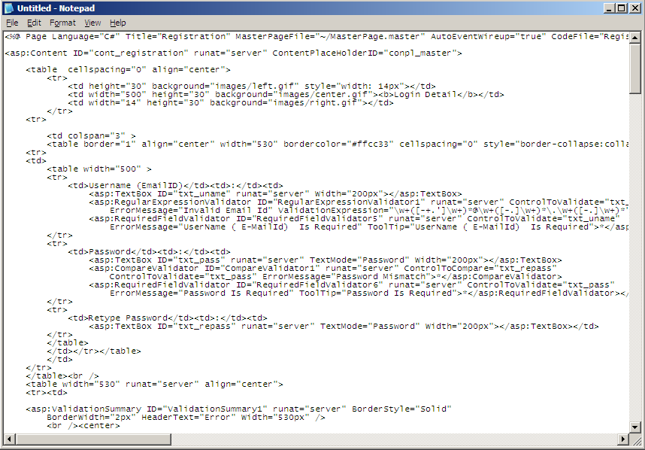

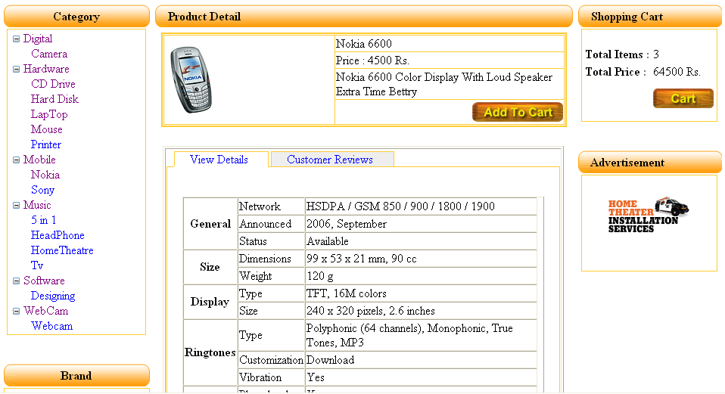
Product Details
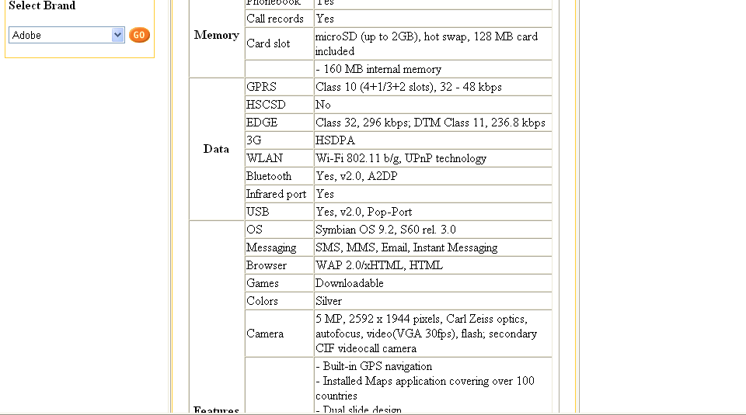
1) Mobile Detail

2) Laptop Detail

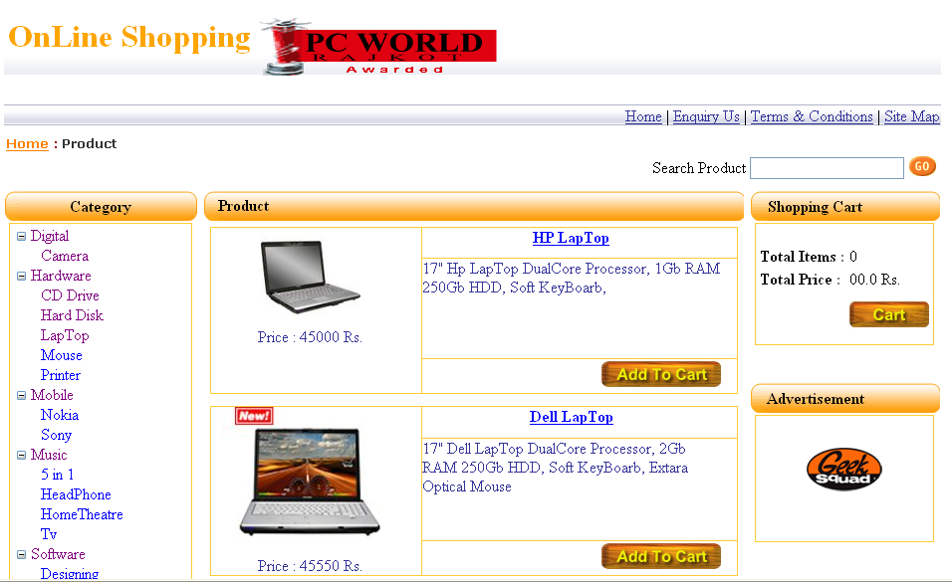
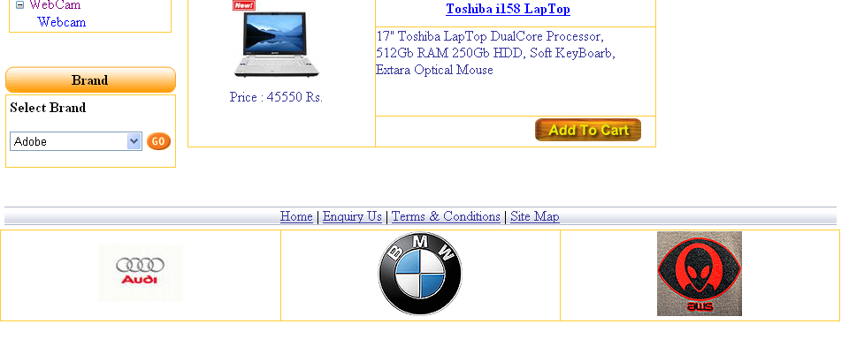

3) Software Detail
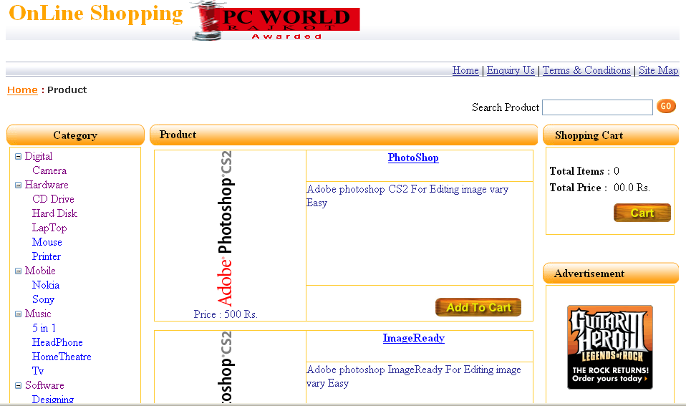
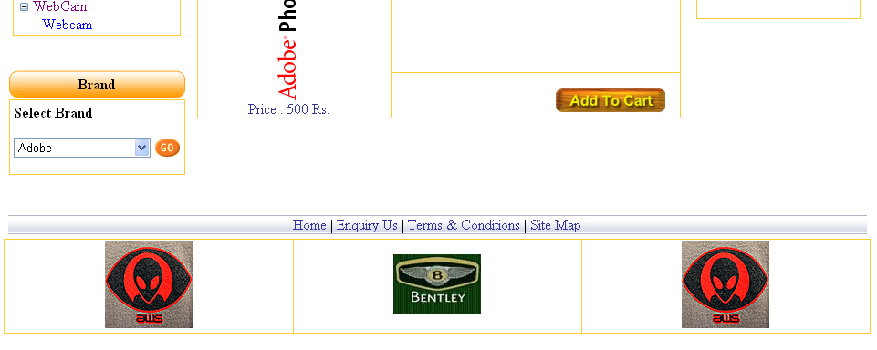

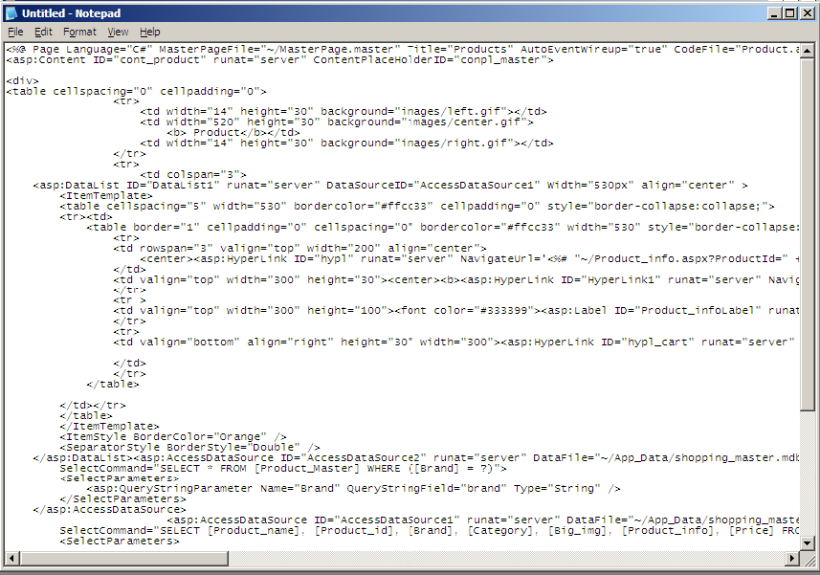
All Product Detail Snipat

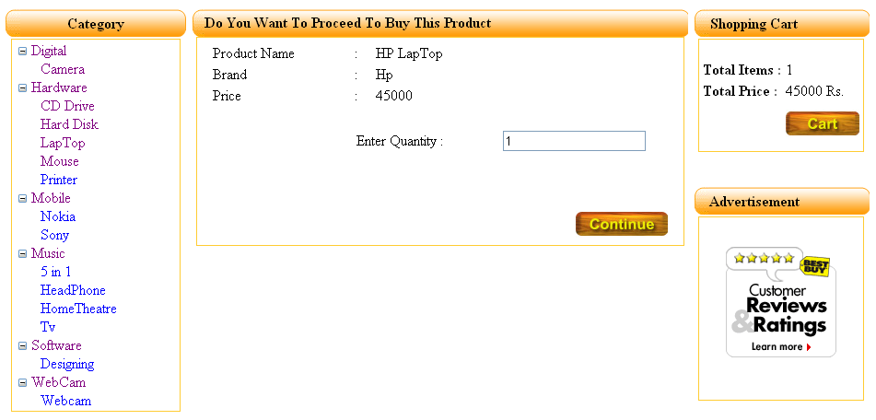
Product Quantity From

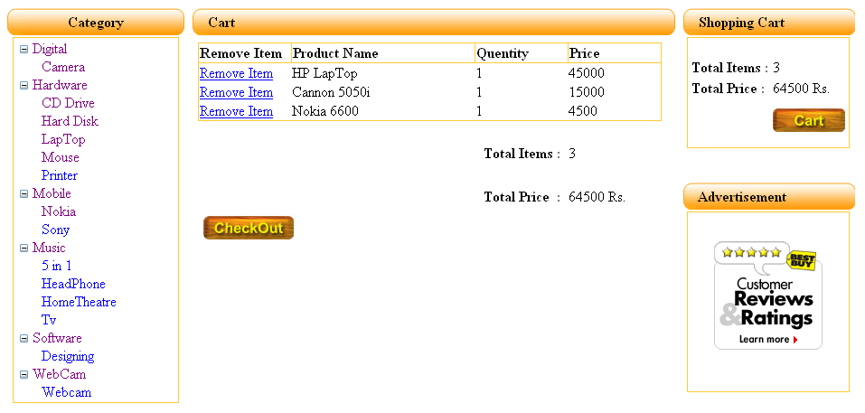
Cart Form
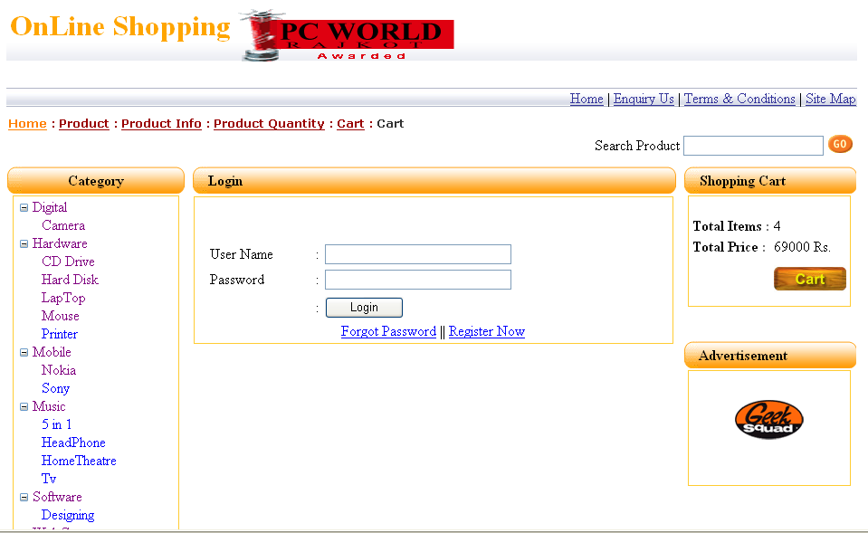
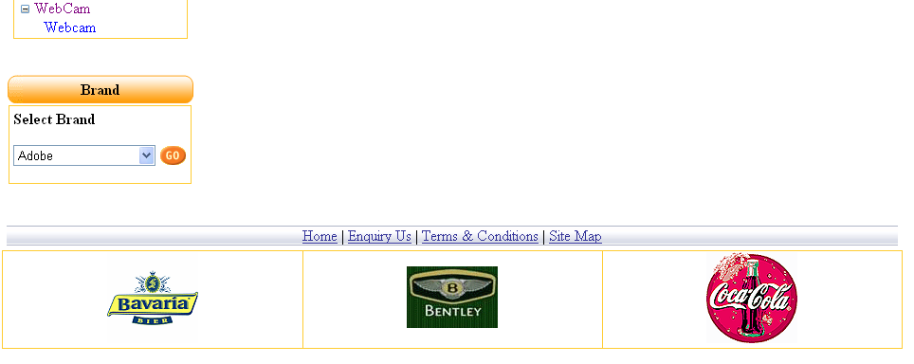

Logout Form

Product Quantity and Cart Snipat
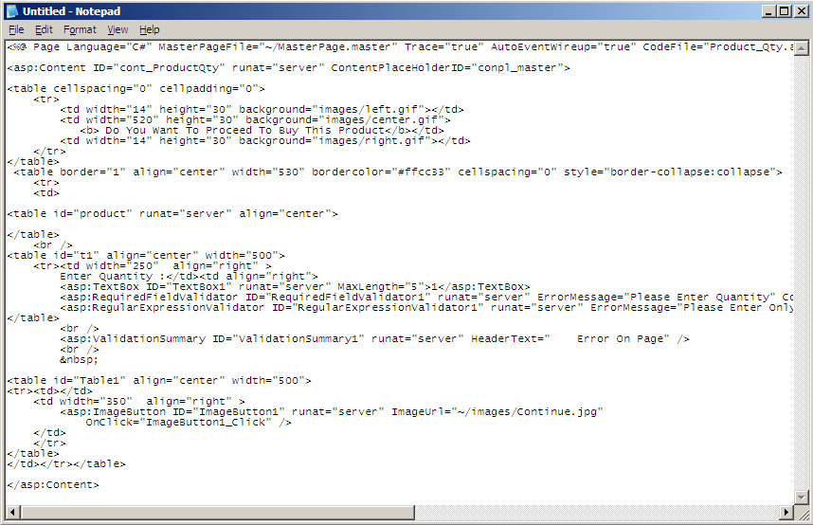

Checkout Snipat
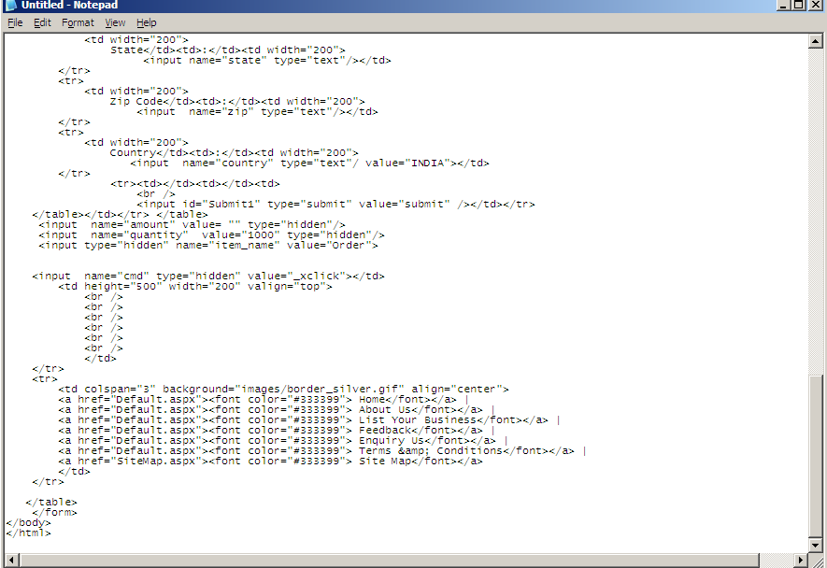

System Testing

Testing is that step to software engineering process that could be viewed as destructive rather than constructive.

In a software development project, errors can be injected at any stage during the development. Also some requirements errors and design errors can remain undetected. Ultimately, these errors will be reflected in the code. Since the code is frequently the only product that can be executed and whose actual behavior can be observed, testing is the phase where the errors remaining form earlier phases also must be detected. Hence, testing performs a very critical role for quality assurance and for ensuring the reliability of the software.

Testing Objectives:-

- Testing is a process of finding the error when the program execute.
- Testing needs high probability for finding the errors.
- A successful testing is to be get from undiscovered errors.

White Box Testing

In this system the testing is to search the undiscovered errors.

White Box Testing is a test case design method that uses the control structure of the procedural design to derive test cases. Using white box testing methods, the software developer can derive test cases.

- Guarantee all paths will redirects the another page as the Individual working place.
- Login page is directed as the Username and Password both are same than go in next page otherwise display the Error. And Put again username and password.

Black Box Testing

Black box testing methods focus on the functional requirements of the software. That is, black box testing enables the software engineer to derive sets of input conditions that will fully exercise all functional requirements for a program.

- Incorrect Information fills in the Project entry, Module entry and Functionality entry Form so generate errors Massage. Means that you can not insert duplicate project name, module name and functionality name related same project.
- In this system when the database structure is different from insert value than give the Error.
- If user is not in right way for accessing the system than Performance error will occur.
- Initialization and termination errors.
- Interface errors

Bibliography

We used many resources for developing this project which is given below.

- Books
  - Mastering ASP.NET with C#
  - Teach Yourself ASP.NET
- Websites
  - www.google.com
  - www.weschool.com

